NCHA Quality Goal: Pledge to Knockout Pneumonia!

Reduce State Pneumonia (PNE) mortality rate by 7.5% to the national average over 2 years. Reduce State PNE readmissions by 5.4% to the national top quartile over 2 years.

Health System:
Hospital(s):

Hospital/Health System Pledges to:
- Work to Reduce my hospital’s PNE mortality rate and support the statewide goal of a 7.5% reduction to move toward the national average over the next 2 years
- Work to Reduce my hospital’s PNE readmission rate and support the statewide goal of a 5.4% reduction over 2 years to the national top quartile
- Commit to review internal performance on the above 2 Pneumonia Measures
- Identify 3 opportunities to improve
- Support nursing homes, home health agencies, ACO and physician practices to sign the partner pledge- this is a community issue!

Teaming Together to Knockout Pneumonia:
- NCHA will provide the local hospital teams CMS data, identify opportunities and provide benchmarking.
- NCHA will provide a Learning and Action Forum in which we will share best practice, convene local experts on various topics and create a peer to peer learning environment.
- The framework for the program will be supported by other key stakeholders who also share this common goal such as the NC Immunization Coalition, Department of Public Health, NC Pharmacy Association, NC Health Care Facilities Association, NC Medical Society, AARP and AHEC.

Signature | Date
Name (Please Print Clearly) | Title
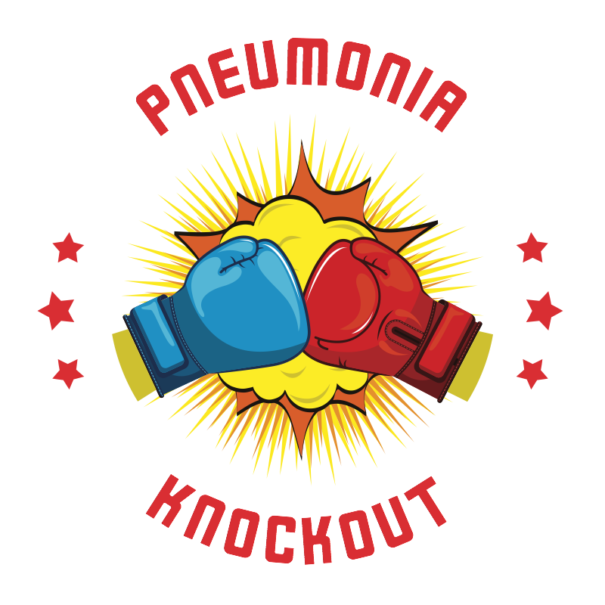
Please return to sroberts@ncha.org

